Save the Time on October 13 from 1pm to 2:30pm
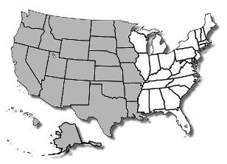 | Western Region Forum of Underearners Anonymous
The Regional Forum is the sharing and information meeting created to help the General Service Board, its Committees, and the General Service Office stay in touch with U.A. Members, Newcomers and Trusted Servants. The purpose of the Forum is to provide connection and service to the UA Fellowship.
Opening and Closing Remarks from UA GSB Chair
GSB Committees Reports
First Responder and Calendar Keeper Reports
UA GSB Trustees Shares
Questions, Shares from the Fellowship

For more information or to be of service, please email Dorota T. at dorotat@uagsb.org

